Product Type: Drywall Stud
Product Definition: 600S125-30 33ksi
CSI Code: 09.22.16.13
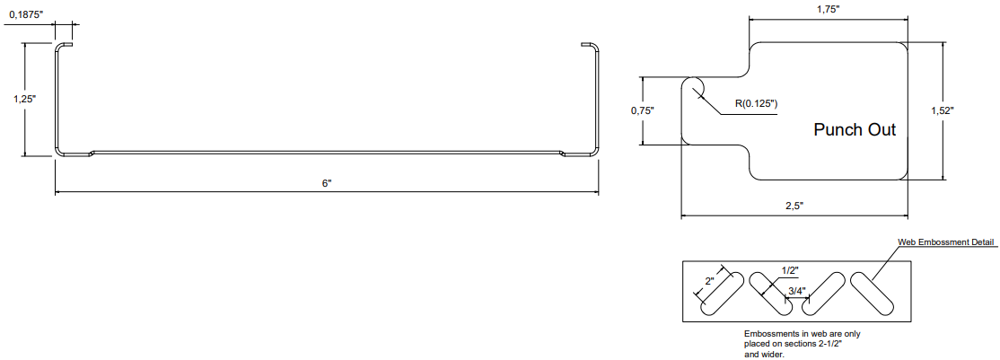

Profile Properties:
Web Depth | 6,000 in | Yield Strength: | 33 ksi
Flange Width | 1,250 in | Unit Weight | 0,91 lb/ft
Stiffening Lip | 0,1875 in | Punchout Width / Length | Please see figure
Design Thickness | 0,0312 in | Finish | G40
Minimum Thickness | 0,0296 in | Color Coding

Gross Section Properties:
Cross Sectional Area | Agross | 0,2692 in2
Moment of Inertia, x-axis | Ix | 1,2854 in4
Radius of Gyration, x-axis | rx | 2,1853 in
Moment of Inertia, y-axis | Iy | 0,0366 in4
Radius of Gyration, y-axis | ry | 0,3688 in

Torsional Properties:
St. Venant Torsion Constant | J x 1000 | 0,0872 in4
Warping Constant | Cw | 0,2522 in6
Distance Between Shear Axis and Neutral Axis | x0 | -0,5790 in
Polar Radius of Gyration | r0 | 2,2906 in
Torsional Flexural Constant | β | 0,9292
Limit of Unbraced Length | Lu | 29,50 in

Effective Section Properties:
Effective Area | Aeff | 0,2588 in2
Effective Moment of Inertia for Deflection | Ixe | 1,2524 in4
Effective Section Modulus | Sxe | 0,4086 in3
Allowable Bending Moment | Ma | 6,8629 in.k
Allowable Shear Force | Vag | 471 lbs

Codes & Standards:
- Calculations are based on AISI S220-20 and AISI S100-16.
- Complies with IBC2021, ASTM C645, ASTM C754, ASTM A653, ASTM A1003, ASTM E72
- Intertek Certificate of Compliance No: COC-WHI23-37729201
- LEED / Sustainability Credits: Environmental Product Declaration S-P Code: S-P-00869

Limiting Heights, Non Composite (ft-in):
Profile | 5 psf |  |  | 7,5 psf |  |  | 10 psf
 | L/120 | L/240 | L/360 | L/120 | L/240 | L/360 | L/120 | L/240 | L/360
12 | 25' 4" | 25' 3" | 22' 1" | 21' 2" | 21' 2" | 19' 3" | 18' 7" | 18' 7" | 17' 6"
16 | 22' 4" | 22' 4" | 20' 1" | 18' 7" | 18' 7" | 17' 6" | 16' 3" | 16' 3" | 15' 11"
24 | 18' 7" | 18' 7" | 17' 6" | 15' 5" | 15' 5" | 15' 4" | 13' 5" | 13' 5" | 13' 5"
- Heights are based on AISI S220-20 and AISI S100-16, using steel properties alone.
- Above listed Non-Composite Limiting Heights are applicable when the unbraced length is less than or equal to Lu. Heights are limited by moment, deflection and shear.

Limiting Heights, Composite – Fully Braced (ft-in):
Profile | 5 psf |  |  | 7,5 psf |  |  | 10 psf
 | L/120 | L/240 | L/360 | L/120 | L/240 | L/360 | L/120 | L/240 | L/360
12 | 34' 2" | 27' 1" | 23' 8" | 28' 11" | 23' 8" | 20' 8" | 25' 0" | 21' 6" | 18' 9"
16 | 30' 8" | 24' 7" | 21' 6" | 25' 0" | 21' 6" | 18' 9" | 21' 8" | 19' 6" | 17' 1"
24 | 25' 0" | 21' 6" | 18' 9" | 20' 5" | 18' 9" | 16' 5" | 17' 8" | 17' 1" | -
- The composite limiting heights are taken from ASTM C754-20 and based on a single layer of 5/8" Type X gypsum board to each stud flange.
- The gypsum board must be applied full height in the vertical orientation in accordance with ASTM C754 using minimum No. 6 Type S Drywall screws.
- Screws shall be spaced a maximum of 16 in on-center to framing members (including top & bottom track] spaced at 16 in or 12 in on-center.
- Screws shall be spaced a maximum of 12 in on-center to framing members (including top & bottom track] spaced at 24 in on-center.
- No fasteners are required for attaching the stud to the track except as detailed in ASTM C754.
- Stud end bearing must be a minimum of 1 inch.

